Issue 1: Hardware Status attribute is displaying the ‘Decomissioned’, ‘Duplicate/Invalid’ and Duplicate/ Invalid’ .

Issue 2: Noticed the Assignment Group/Locations are ‘UNSPECIFIED’ for the previous months.

Issue 3: Location has multiple ID forms.

Issue 4: Below metrics are displaying 0.

Managed Count

Valid_unregistered _count_c

unregistered_disposable _watchlist_count_c.

Clarification : This is snapshots hold for both Service now and Tenable, if yes how can we differentiate?

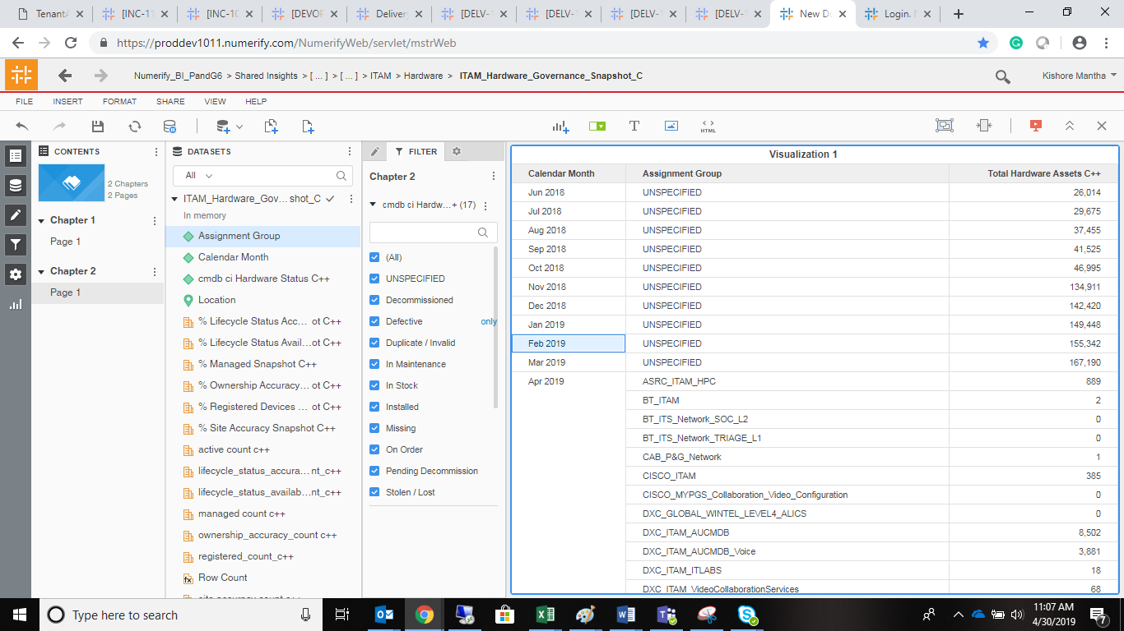

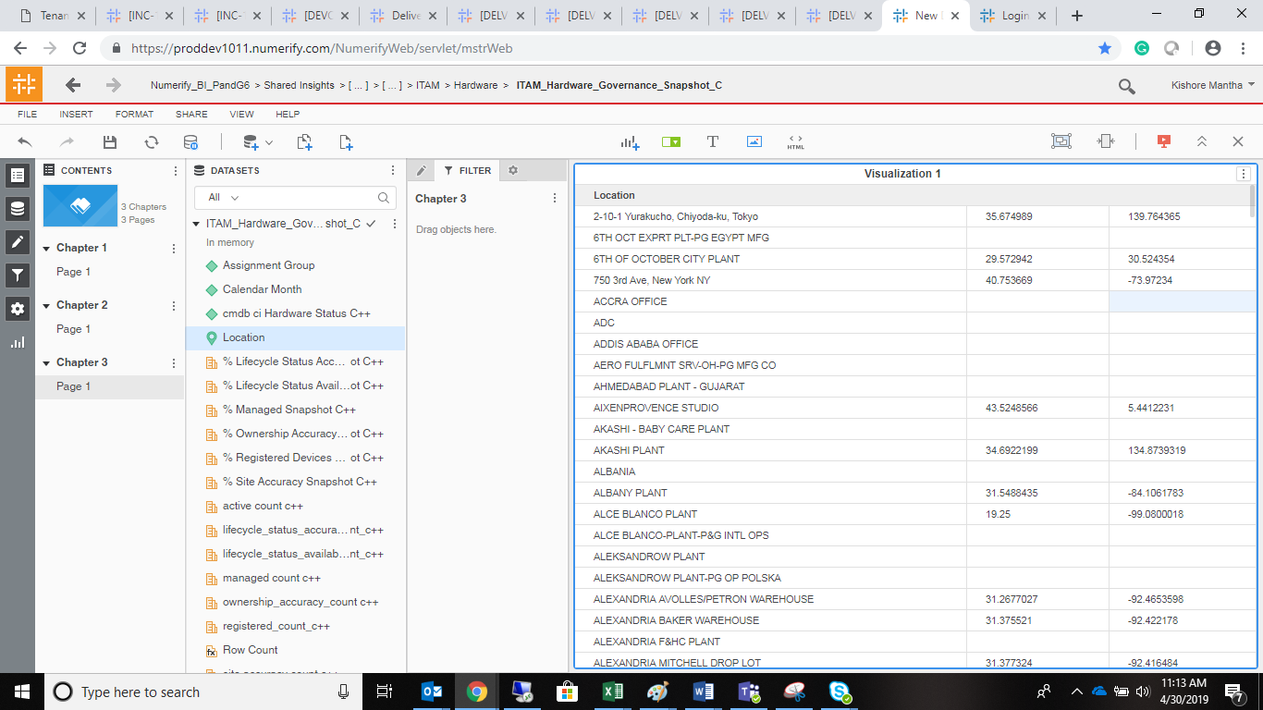

Location unspecified :

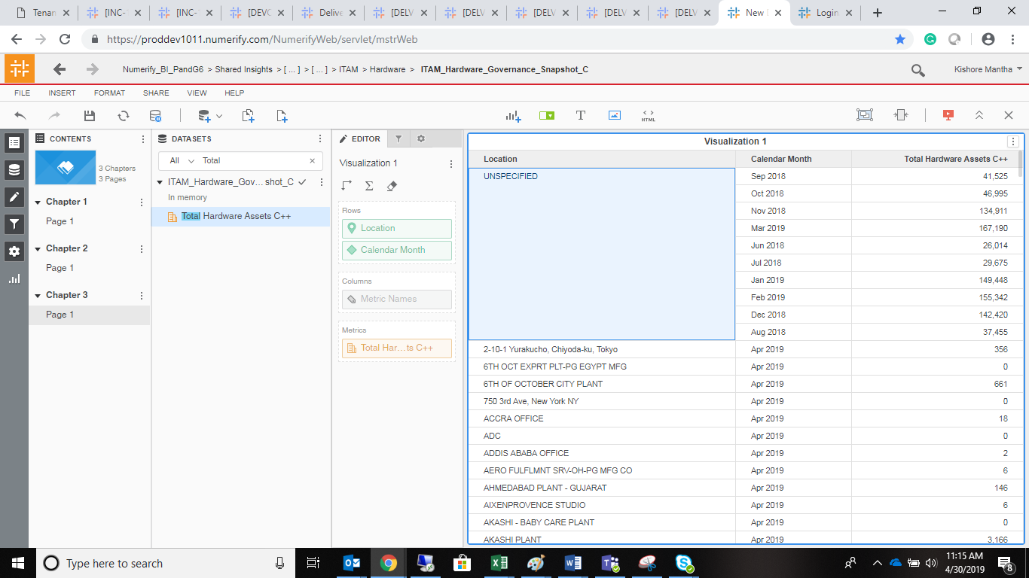

Issue 4:

